Captain Nicole D. Rodriguez, USCG

Commander, U.S. Coast Guard Sector Houston-Galveston

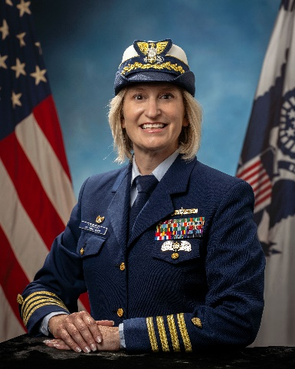
Captain Nicole Rodriguez assumed the duties as Commander, Sector Houston-Galveston in April 2025. As the Sector Commander and Captain of the Port, she directs over 1,400 personnel in execution of all Coast Guard missions from the Colorado River in southwest Texas to 60 miles east of Lake Charles, Louisiana and 200 miles offshore. Prior to this assignment, Captain Rodriguez served as the Deputy Commander of Sector Houston-Galveston.

Previous Command assignments include Commanding Officer of Marine Safety Unit Lake Charles (2021- 2023) overseeing all maritime operations over an 8,400 square mile area of responsibility in Southwest Louisiana; and Commanding Officer of Marine Safety Unit Baton Rouge (2013-2016) where she served as Field Commander in execution of Captain of the Port, Officer in Charge of Marine Inspection, Federal On-Scene Coordinator, and Federal Maritime Security Coordinator authorities.

As a maritime professional she has served as Chief of Prevention for Sector Houston-Galveston where she oversaw foreign and domestic vessel compliance, port facility safety and security, ports and waterways management, aids to navigation, and marine causality investigation; Chief of the Investigations Division for Sector Baltimore; and, marine inspector and port operations officer for Group/Marine Safety Office Los Angeles-Long Beach.

Previous staff tours include assignment as Chief of Inspections and Investigations for the Coast Guard Heartland District headquartered in New Orleans, where she was responsible for the District’s marine safety, security, and stewardship initiatives for 26 states including the inland waterways system and Gulf of Mexico. Additionally, she served as Program Reviewer for the Coast Guard’s Human Resources directorate, the Offices of Shore and Boat Forces, and Search and Rescue Directorate while assigned to the Office of Budget and Programs at Coast Guard Headquarters in Washington, D.C.

Captain Rodriguez is a prior recipient of the Congressman James Sener Award for Excellence in Marine Investigations and is certified as a Maritime Port Executive. She has earned both the Prevention and Response Operations Ashore insignias and is an honorary Admiral in the Texas Navy. She holds a Bachelor of Arts from James Madison University and a Masters in Public Administration from The George Washington University.

